# **13 Oracle Database Link**

* A database link is a connection from the Oracle database to another remote database. The remote database can be an Oracle Database or any ODBC database such as SQL Server or MySQL.

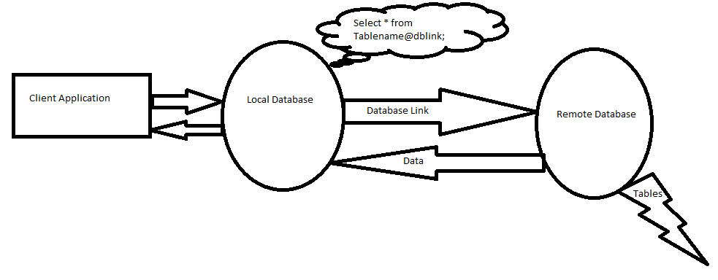

* Once you create a database link it allows user to access database objects such as tables and views from another database.
* We can perform only DML operations.through database links. (**insert, update, delete**).
* We cannot perform DDL operations.
* Private db link is recommended to create.

**Requirement’s to create database link**

* Source user id and password required.
* Listener in source side and TNS of source database in target side.
* User must have create database link previlige (from which user we are creating db link).

**To check database link status**

* desc dba_db_links
* select * from dba_db_links;

**Database links are two types**.

1. **private db link**
2. **Public db link**

**To create private database link**

* Only created user can access the private db link
* Conn mouli/mouli

SQL> create database link LINK_JMS connect to u1 identified by u1 using ‘JMSDB’;

**To create public database link**

* Any user can create public db link.
* Any user in the database can access this db link.
* Creating user should have **public** link creating grant.

SQL> create public database link LINK_1 connect to u1 identified by u1 using ‘tns_hyd’;

**To check link is working or not**

* SELECT * from dual@LINK_JMS;

**To view source data**

* select * from t1@LINK_1;

**To insert data in u1 from mouli:**

* desc t1@ LINK_1
* insert into t1LINK_1 values (1,’mouli’,’kkd’);
* After insert commit.

**To update data in u1 from mouli:**

* update t1@LINK_1 set emloc=‘samalkot’ where eno=3;
* after update commit.

**To delete data in u1 from mouli:**

* delete from t1@LINK_1 where eno=3;
* after update commit.

**To drop database links**:

* private db link can dropped by who created it.
* drop database link link_1;

&

* any user can drop public link.
* drop public database link link_1.